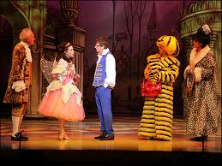
Pantomime

We are attending the Pantomime in Lurgan Town Hall on Friday 25th November. This year the Pantomime is “Santa’s Sooty Christmas.” Please remember to collect your child from THE TOWN HALL at 12.30pm. We have reserved seats at the front of the Hall and the children will stay in their seats until they are collected so please come into the Town Hall for your child. There will be no school meals on that day. If you are unsure about where the Town Hall is please speak to a member of staff. Please DO NOT park your car on the double yellow lines as the last time we requested for the children to be collected from the town hall quite a few people got issued with parking tickets – you have been warned! Please complete the consent at the bottom of this news and return it to school (with £3 towards the cost of the ticket) as soon as possible.

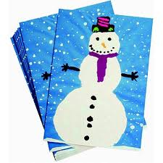
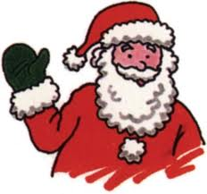
PLEASE LET US KNOW IF YOUR CHILD IS AFRAID OF SANTA

Christmas cards

You are welcome to allow your child to bring in Christmas cards next month for his/her friends – use the information wallets in the entrance hall to distribute these. Please do not feel it is necessary to send a card to every child in the class but allow your child to suggest a few names of those they play with most often and send cards to these children only.

Contribution

We would really appreciate a contribution of one pack of toilet rolls, one box of tissues & a bottle of blue ‘Dove’ liquid soap. Many thanks for your help with this.

Parenting course & leaflets

Many thanks to the 10 parents who have attended the 3 week course, we hope that you have found it informative & enjoyable. We also hope that you are enjoying the short series of information leaflets about the learning linked to various activities in school. Please do not hesitate to speak to Mrs Edwards or Mrs Hunter if you have any questions about any of this information.

I give permission for _________________________ to go to Lurgan Town Hall to see ‘Santa’s

Sooty Christmas on Friday 25th November. I enclose £3 towards the cost of the ticket.

Signed __________________________________ Date _____________________

